Height of a Cylinder
# Source: AI Source: Provided by: [Data Path: Persons Table -> ID Column: 1, Name_En Column: Motasem Essam] -> From: [ChatGPT] on [7/25/2026]
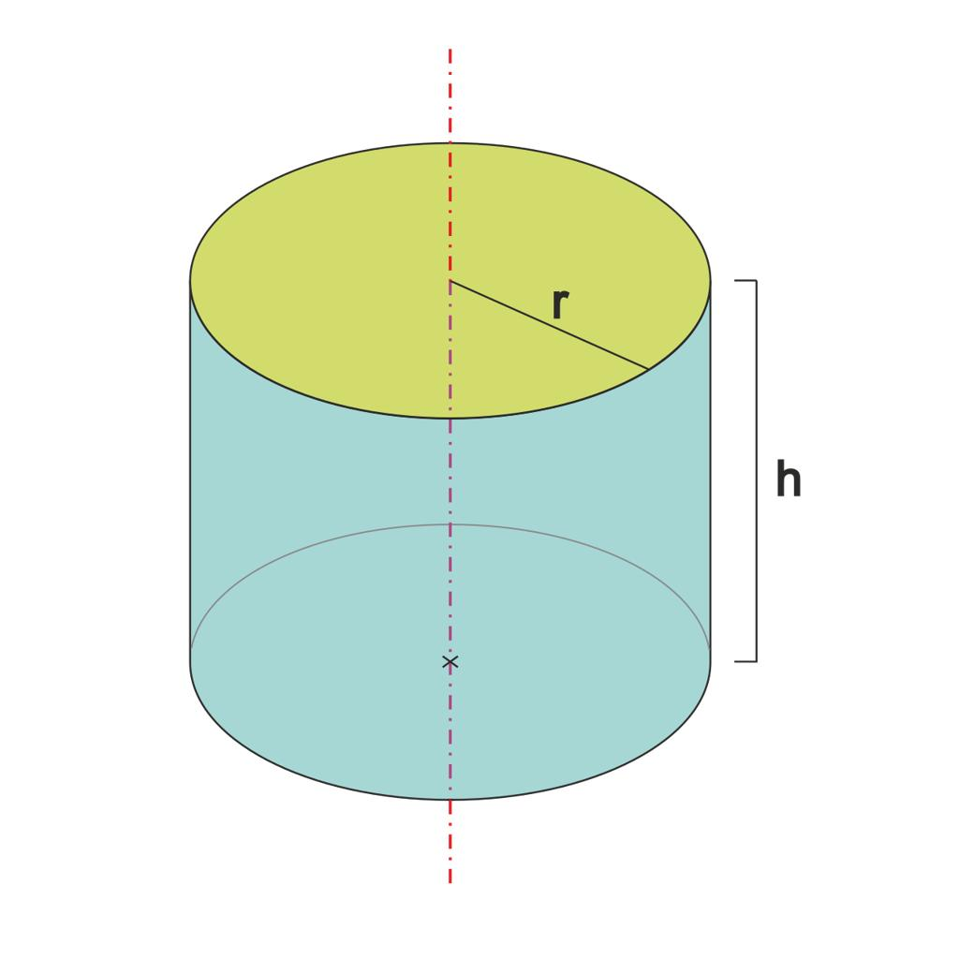
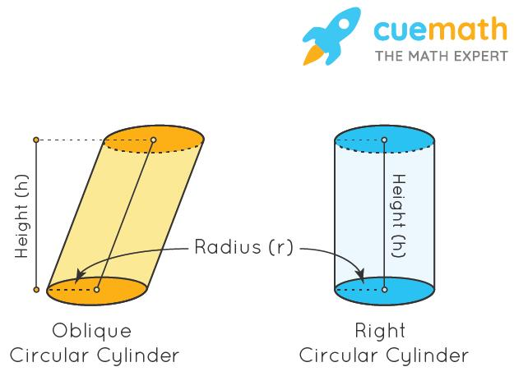
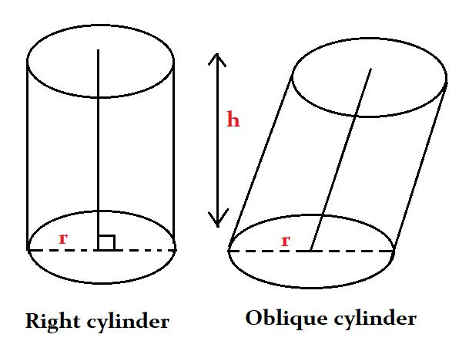

Definition
# Source: AI Source: Provided by: [Data Path: Persons Table -> ID Column: 1, Name_En Column: Motasem Essam] -> From: [ChatGPT] on [7/25/2026]
The height of a cylinder is the perpendicular distance between the planes containing its two circular bases. It measures how far apart the top and bottom bases are, rather than the distance along the curved surface or a slanted side.
For a right circular cylinder, the height is parallel to the cylinder's axis and perpendicular to both bases. For an oblique circular cylinder, the height is still measured perpendicularly between the base planes, even though the axis is inclined.

Simple Definition
# Source: AI Source: Provided by: [Data Path: Persons Table -> ID Column: 1, Name_En Column: Motasem Essam] -> From: [ChatGPT] on [7/25/2026]
The height is the straight, perpendicular distance between the top and bottom bases of a cylinder.
It is usually represented by $h$ and measured in linear units such as centimetres or metres.

Geometric Representation and Components
# Source: AI Source: Provided by: [Data Path: Persons Table -> ID Column: 1, Name_En Column: Motasem Essam] -> From: [ChatGPT] on [7/25/2026]
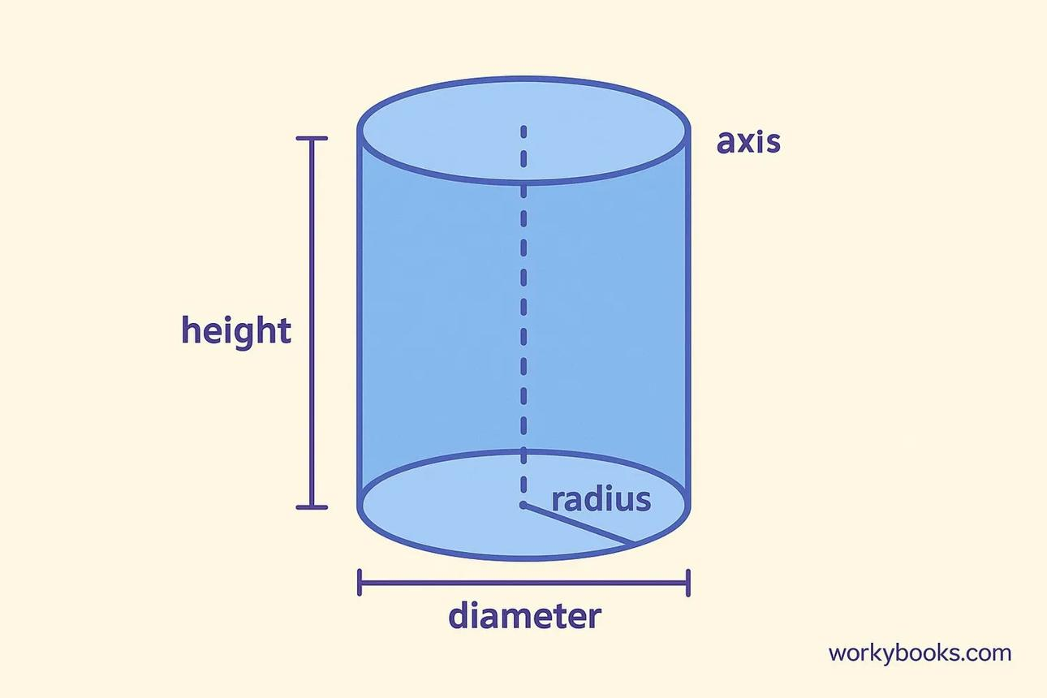
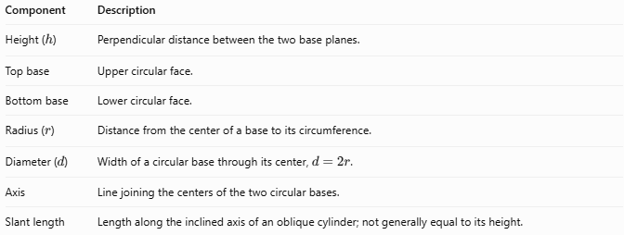
Component | Description
Height ($h$) | Perpendicular distance between the two base planes.
Top base | Upper circular face.
Bottom base | Lower circular face.
Radius ($r$) | Distance from the center of a base to its circumference.
Diameter ($d$) | Width of a circular base through its center, $d=2r$.
Axis | Line joining the centers of the two circular bases.
Slant length | Length along the inclined axis of an oblique cylinder; not generally equal to its height.

4. Types and Classification

Height of a Right Circular Cylinder
# Source: AI Source: Provided by: [Data Path: Persons Table -> ID Column: 1, Name_En Column: Motasem Essam] -> From: [ChatGPT] on [7/25/2026]
In a right circular cylinder, the axis is perpendicular to the bases. Therefore, the height is equal to the length of the axis segment between the base centers.
$$\boxed{h=\text{axis length}}$$

eight of an Oblique Circular Cylinder
# Source: AI Source: Provided by: [Data Path: Persons Table -> ID Column: 1, Name_En Column: Motasem Essam] -> From: [ChatGPT] on [7/25/2026]
In an oblique circular cylinder, the axis is inclined to the bases. The height is the shortest distance between the parallel base planes, measured along a perpendicular line.
Consequently, the height is generally shorter than the axis length.

Height of a Hollow Cylinder
# Source: AI Source: Provided by: [Data Path: Persons Table -> ID Column: 1, Name_En Column: Motasem Essam] -> From: [ChatGPT] on [7/25/2026]
For a hollow cylinder, the height is the perpendicular distance between its two annular ends. The fact that the cylinder is hollow does not change the definition of height.

Mathematical Formulas

Height from the Volume
# Source: AI Source: Provided by: [Data Path: Persons Table -> ID Column: 1, Name_En Column: Motasem Essam] -> From: [ChatGPT] on [7/25/2026]
The volume of a circular cylinder is:
$$V=πr^{2}h$$
Rearranging to find the height:
$$\boxed{h=\frac{V}{πr^{2}}}$$
Using the diameter $d=2r$:
$$\boxed{h=\frac{4V}{πd^{2}}}$$

Height from the Lateral Surface Area
# Source: AI Source: Provided by: [Data Path: Persons Table -> ID Column: 1, Name_En Column: Motasem Essam] -> From: [ChatGPT] on [7/25/2026]
For a right circular cylinder, the curved lateral surface area is:
$$A_{L}=2πrh$$
Therefore:
$$\boxed{h=\frac{A_{L}}{2πr}}$$
Using the diameter:
$$\boxed{h=\frac{A_{L}}{πd}}$$

Height from the Total Surface Area
# Source: AI Source: Provided by: [Data Path: Persons Table -> ID Column: 1, Name_En Column: Motasem Essam] -> From: [ChatGPT] on [7/25/2026]
For a closed right circular cylinder:
$$A_{T}=2πr^{2}+2πrh$$
Rearranging:
$$\boxed{h=\frac{A_{T}-2πr^{2}}{2πr}}$$
This formula includes both circular bases and the curved lateral surface.

Height from the Slant Length of an Oblique Cylinder
# Source: AI Source: Provided by: [Data Path: Persons Table -> ID Column: 1, Name_En Column: Motasem Essam] -> From: [ChatGPT] on [7/25/2026]
For an oblique circular cylinder, if the axis length is $s$ and the angle between the axis and the perpendicular direction to the base planes is $θ$, then:
$$\boxed{h=s\cos{θ}}$$
Here, $θ$ is measured from the perpendicular direction. If the angle $α$ is measured between the axis and the base plane instead, then:
$$\boxed{h=s\sin{α}}$$
These relationships apply when the specified slant length is the length of the axis segment between the base centers.

Worked Examples
# Source: AI Source: Provided by: [Data Path: Persons Table -> ID Column: 1, Name_En Column: Motasem Essam] -> From: [ChatGPT] on [7/25/2026]
Example 1 — Find the Height from the Volume
A cylinder has a volume of $300π{\text{ cm}}^{3}$ and a radius of $5\text{ cm}$. Find its height.
Given:
$$V=300π{\text{ cm}}^{3}, r=5\text{ cm}$$
Solution:
$$h=\frac{V}{πr^{2}}$$
$$h=\frac{300π}{π{\left(5\right)}^{2}}$$
$$h=\frac{300π}{25π}$$
$$\boxed{h=12\text{ cm}}$$
Example 2 — Find the Height from the Lateral Surface Area
A right circular cylinder has a radius of $4\text{ m}$ and a curved lateral surface area of $96π{\text{ m}}^{2}$. Find its height.
Solution:
$$h=\frac{A_{L}}{2πr}$$
$$h=\frac{96π}{2π\left(4\right)}$$
$$h=\frac{96π}{8π}$$
$$\boxed{h=12\text{ m}}$$
Example 3 — Find the Height from the Total Surface Area
A closed right circular cylinder has a radius of $3\text{ cm}$ and a total surface area of $90π{\text{ cm}}^{2}$. Find its height.
Solution:
$$h=\frac{A_{T}-2πr^{2}}{2πr}$$
Substitute the given values:
$$h=\frac{90π-2π{\left(3\right)}^{2}}{2π\left(3\right)}$$
$$h=\frac{90π-18π}{6π}$$
$$h=\frac{72π}{6π}$$
$$\boxed{h=12\text{ cm}}$$
Example 4 — Find the Height of an Oblique Cylinder
An oblique cylinder has an axis length of $10\text{ cm}$. The axis makes an angle of ${30}^{∘}$ with the base plane. Find its perpendicular height.
Solution:
$$h=s\sin{α}$$
$$h=10{\sin{30}}^{∘}$$
Since ${\sin{30}}^{∘}=\frac{1}{2}$:
$$\boxed{h=5\text{ cm}}$$

How Height Affects a Cylinder
# Source: AI Source: Provided by: [Data Path: Persons Table -> ID Column: 1, Name_En Column: Motasem Essam] -> From: [ChatGPT] on [7/25/2026]
For a circular cylinder with a fixed radius:
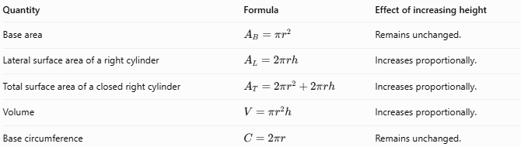
Quantity | Formula | Effect of increasing height
Base area | $$A_{B}=πr^{2}$$ | Remains unchanged.
Lateral surface area of a right cylinder | $$A_{L}=2πrh$$ | Increases proportionally.
Total surface area of a closed right cylinder | $$A_{T}=2πr^{2}+2πrh$$ | Increases proportionally.
Volume | $$V=πr^{2}h$$ | Increases proportionally.
Base circumference | $$C=2πr$$ | Remains unchanged.
For example, if the height doubles while the radius remains constant, the volume and lateral surface area of a right circular cylinder both double.

Height Compared with Related Measurements
# Source: AI Source: Provided by: [Data Path: Persons Table -> ID Column: 1, Name_En Column: Motasem Essam] -> From: [ChatGPT] on [7/25/2026]
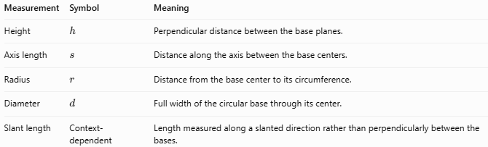
Measurement | Symbol | Meaning
Height | $$h$$ | Perpendicular distance between the base planes.
Axis length | $$s$$ | Distance along the axis between the base centers.
Radius | $$r$$ | Distance from the base center to its circumference.
Diameter | $$d$$ | Full width of the circular base through its center.
Slant length | Context-dependent | Length measured along a slanted direction rather than perpendicularly between the bases.
Important distinction: The height is not necessarily the length of the slanted axis. They are equal for a right circular cylinder but generally differ for an oblique cylinder.

Applications
# Source: AI Source: Provided by: [Data Path: Persons Table -> ID Column: 1, Name_En Column: Motasem Essam] -> From: [ChatGPT] on [7/25/2026]
The height of a cylinder is useful in:
- Water tanks: calculating storage capacity.
- Cans and containers: determining internal volume.
- Pipes: measuring the length of a cylindrical section between its ends.
- Construction: calculating the volume of cylindrical columns and foundations.
- Manufacturing: specifying the dimensions of cylindrical components.
- Engineering: determining material requirements and capacity for cylindrical structures.
When calculating volume, use the perpendicular height, not an inclined axis length.

Key Points
# Source: AI Source: Provided by: [Data Path: Persons Table -> ID Column: 1, Name_En Column: Motasem Essam] -> From: [ChatGPT] on [7/25/2026]
- The height is the perpendicular distance between the two base planes.
- It is commonly represented by $h$.
- The height equals the axis length in a right circular cylinder.
- In an oblique cylinder, the height is generally shorter than the axis length.
- The volume formula is $V=πr^{2}h$.
- The formula $A_{L}=2πrh$ applies directly to the lateral surface area of a right circular cylinder.
- Height is measured in linear units; surface area uses square units, and volume uses cubic units.

Conclusion
The height of a cylinder is the perpendicular distance between its two parallel circular bases. It is essential for calculating volume and, for a right circular cylinder, lateral and total surface area.
The two most useful formulas for finding height are:
$$\boxed{h=\frac{V}{πr^{2}}}$$
$$\boxed{h=\frac{A_{L}}{2πr}}$$
The second formula applies to a right circular cylinder.

